**Conjoint Analysis**

**Figure 1** is the fake survey data I used to test out my code.

Each row represents one respondent, with a total of 10 respondents.

Each column represents the different combinations of Planning, Product Performance, Training and Costs. The 9 different combinations are shown below in **Figure 2**.

For example, Obs1 q1: The first respondent rated the combination of 3D Isometric Drawings, Reduction of Shutdown time, Online class training and cost of scaffold as a 1 out of 10.

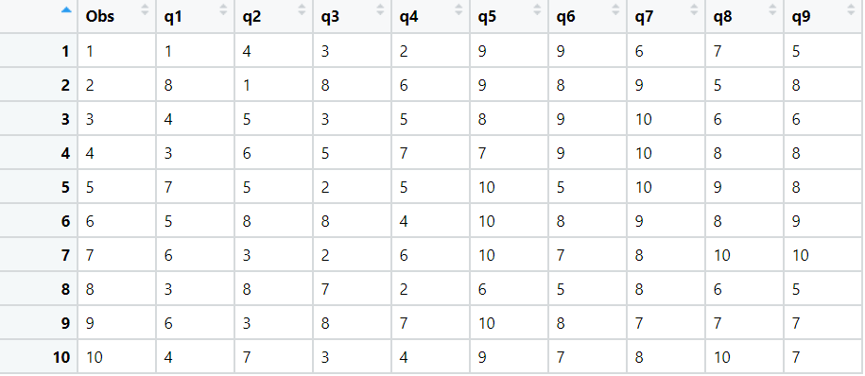 **Figure 1 below**

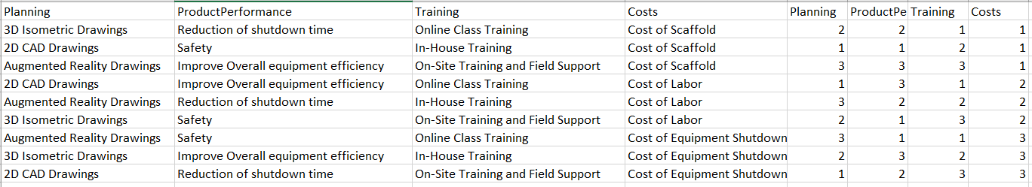 **Figure 2 below**

**Output:**

**Overall Importance**

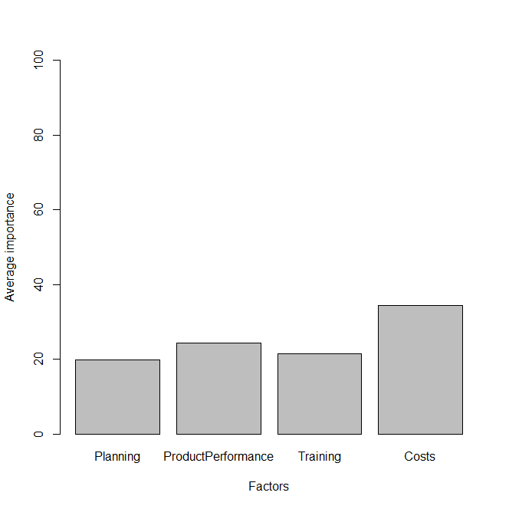

Out of the four factors, Costs seem to be the most important factor to the customers, followed by product performance, planning and training.

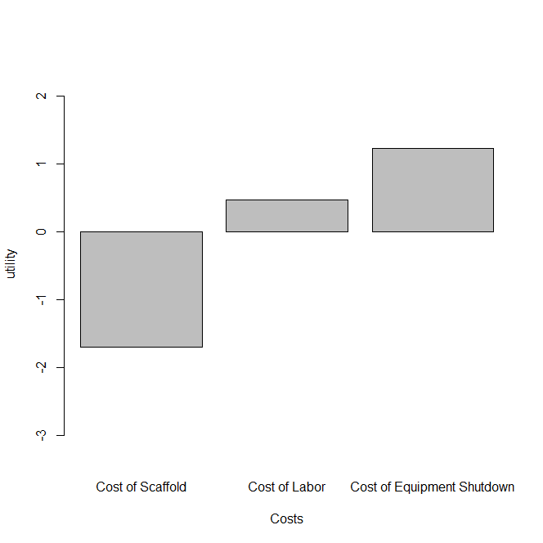**Importance within factor:**

Further looking into Costs, Equipment shutdown seems to be the most valued feature to the customers while the cost of scaffold seem to be the least important.

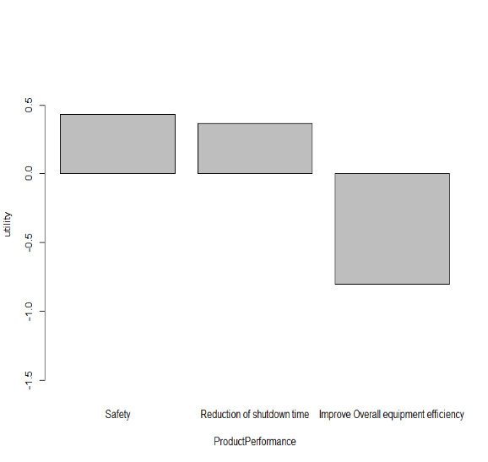

Safety and reduction of shutdown time are more important features that the customers value within Product performance.

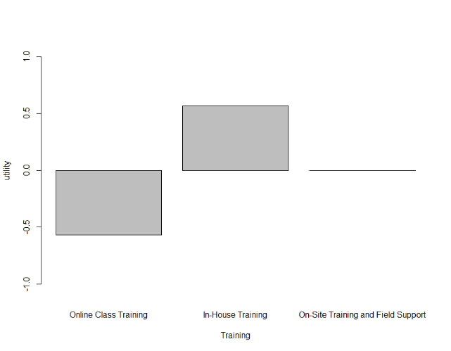

Customers value In-house training the most, On site training does not factor much into their decision, while Online class training negatively impacts their decision.

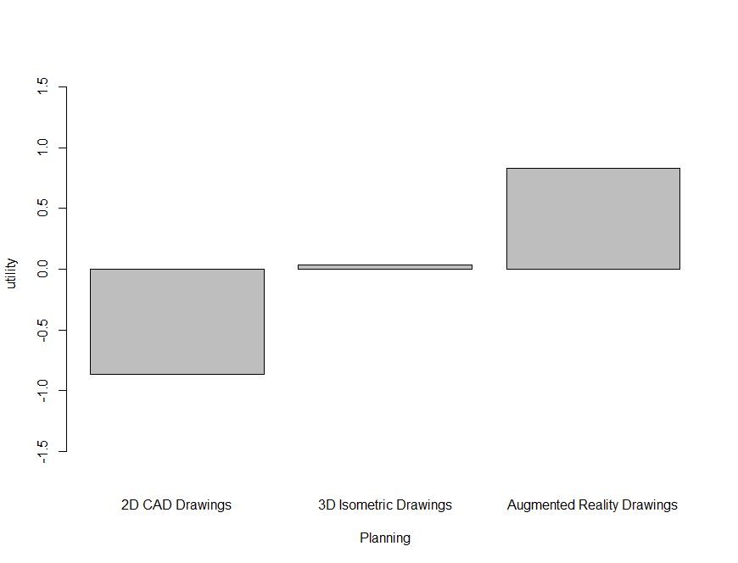

Augmented Reality Drawings are preferred over 2D CAD Drawings and 3D Isometric Drawings.